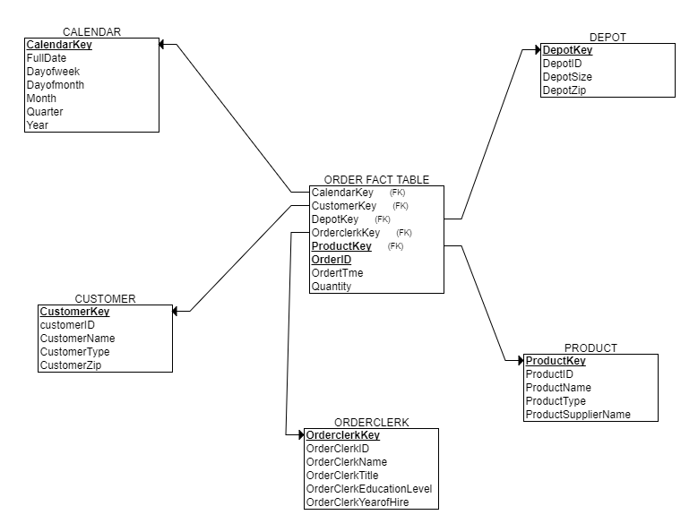

**Calendar Dimension**

|  |  |  |  |  |  |  |
| --- | --- | --- | --- | --- | --- | --- |
| CalendarKey | FullDate | DayofWeek | DayofMonth | Month | Quarter | Year |
| 1 | 1/1/2013 | Tuesday | 1 | 1 | 1 | 2013 |
| 2 | 1/2/2013 | Wednesday | 2 | 1 | 1 | 2013 |
| 3 | 1/3/2013 | Thursday | 3 | 1 | 1 | 2013 |

|  |  |  |  |  |
| --- | --- | --- | --- | --- |
| **Customer Dimension** |  |  |  |  |
| CustomerKey | CustomertD | CustomerName | CustomerType | CustomerZip |
| 1 | C1 | Auto Doc | Repair Shop | 60137 |
| 2 | C2 | Bo's Car Repair | Repair Shop | 60140 |
| 3 | C3 | JJ Auto Parts | Retailer | 60605 |

|  |  |  |  |
| --- | --- | --- | --- |
| **Depot Dimension** |  |  |  |
| DepotKey | DepotID | DepotSize | DepotZip |
| 1 | D1 | Small | 60611 |
| 2 | D2 | Large | 60660 |
| 3 | D3 | Large | 60611 |

|  |  |  |  |  |
| --- | --- | --- | --- | --- |
| **Product Dimension** |  |  |  |  |
| ProductKey | ProductlD | ProductName | ProductType | ProductSupplierName |
| 1 | P1 | BigGripper | Tire | Super Tires |
| 2 | P2 | TractionWiz | Tire | Super Tires |
| 3 | P3 | SureStart | Battery | Batteries Etc |

|  |  |  |  |  |  |
| --- | --- | --- | --- | --- | --- |
| **OrderClerk Dimension** |  |  |  |  |  |
| Order  ClerkKey | Order  ClerklD | Order  ClerkName | Order  ClerkTitle | OrderClerk  EducationLevel | OrderClerk  YearofHire |
| 1 | 1 | Antonio | Order Clerk | High School | 2001 |
| 2 | 2 | Wesley | Order Clerk | College | 2005 |
| 3 | 3 | Lily | Order Clerk | College | 2005 |

|  |  |  |  |  |  |  |  |
| --- | --- | --- | --- | --- | --- | --- | --- |
| **Order Fact Table** |  |  |  |  |  |  |  |
| CalendarKey | CustomerKey | DepotKey | ProductKey | OderclerkKey | OrderID | Quantity | OrderTime |
| 1 | 1 | 1 | 1 | 1 | O1 | 4 | 9:00 AM |
| 1 | 1 | 1 | 2 | 1 | O1 | 8 | 9:00 AM |
| 2 | 2 | 1 | 1 | 2 | O2 | 12 | 9:00 AM |
| 2 | 3 | 2 | 2 | 3 | O3 | 4 | 9:30 AM |
| 3 | 1 | 2 | 3 | 1 | O4 | 7 | 9:00 AM |
| 3 | 2 | 3 | 3 | 2 | O5 | 5 | 9:15 AM |
| 3 | 3 | 3 | 2 | 3 | O6 | 8 | 9:30 AM |
| 3 | 3 | 3 | 1 | 3 | O6 | 4 | 9:30 AM |